**Assignment 1**

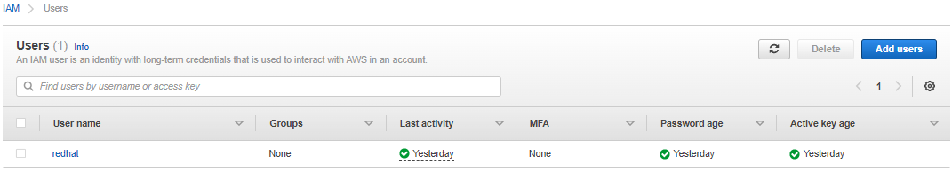

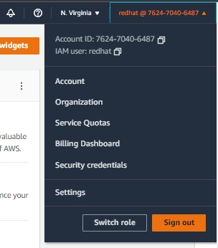

**Assignment 2**

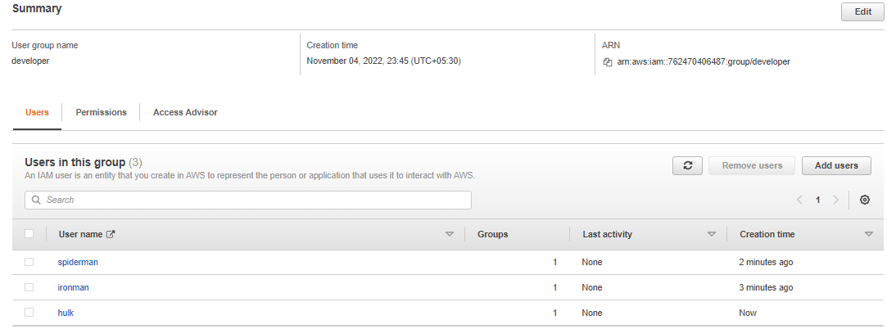

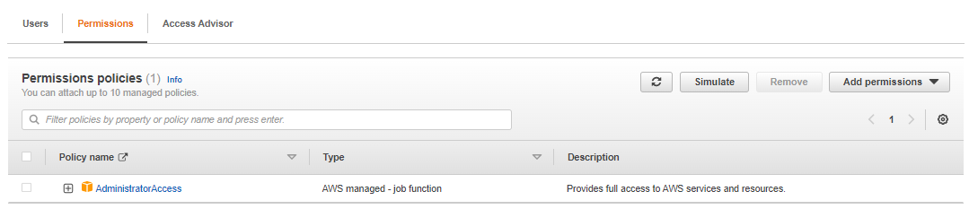

**Assignment 3**

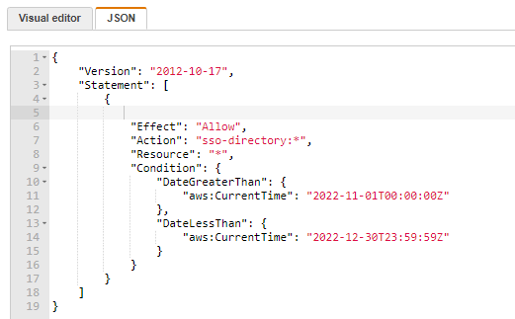

**Assignment 4**

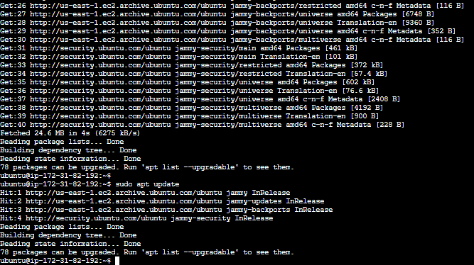

QUESTION:-

1. Which of the following is the most secure way of giving access to AWS services to applications running on Ec2 instances?

A. Creating service users

B. Creating service group

C. Roles

D. Attaching policies to application

2. Which of the following sections in a policy specifies the entities to whom access to a resource is granted or denied?

A. Statement ID

B. Resources

C. Principal

D. Conditions

3. What’s the other name of the IAM user?

A. IAM entity

B. IAM center

C. IAM management user

D. IAM

4. What are Temporary Security Credentials?

5. What is the IAM Hierarchy of Privileges?

6. Which of the following is an IAM Security Tools

A. IAM credential Report

B. IAM root account manager

C. IAM service report

D. IAM security advisor

7. What is the functionality of policy simulator and how it works?

8. What is meant by security token service?

9. If there is group create then what is the use of identity provider?

10. What is the difference between users and roles in IAM?

11. Which of the following is not a feature of AWS Security Token Service?

A. STS enables you to request temporary, limited-privilege credentials.

B. STS enables users to assume role.

C. STS generates Git Credentials for IAM users.

D. STS generates Federated Credentials for IAM users.